PROJECT HABITAR



SCIENTIFIC PROJECT OF RESEARCH AND DEVELOPMENT FOR AN ISOLATED TRAINING CENTER OF SIMULATION OF INTERPLANETARY COLONIZATION.

Team Members:

ÁLVAREZ DE IGARZÁBAL, Fernando Héctor.

BUCHARDO, Rubén Alejandro.

CASTRO, Oscar Raúl Andrés.

GÓNGORA, David Alejandro.

LEÓN, Juan Emilio.

Published: 05/05/2017

Faculties that integrate Púlsar Research and Development



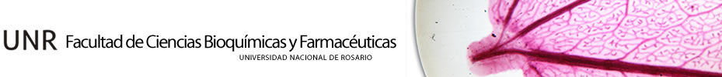



Total professional hours worked: 357hs

Index

Some memories about Space Apps 2016 6

Appointmenta to the introduction of Éffictron 2016.- 6

Progress of Project Éffictron 7

Dictionary of Project HábitAR 8

Category: Ideate and create. 9

Description 9

Situation: 9

Considerations: 10

General Planning. 11

National instance 11

International instance 11

Post-Preliminary draft Instance 11

Project execution instance 12

Introduction to project HábitAR 12

Mission plan & simulation 19

1.- Living Place 21

1 a.- Havens: Temporary shelters 21

HAVEN-Alpha 22

HAVEN-Beta 22

1 b.- Main HábitAR 22

1 c.- Rover’s Haven 26

2.- Energy infrastructure 26

2 a.- Main source: Nuclear Energy based on RTG 26

2 b.- Secondary and contingency source: Photovoltaic Solar Energy 28

3.- Tangible Resource Production 28

4.- MMBM (MULTIPURPOSE MARTIAN BUILDER MACHINE) 29

Martian construction materials 30

4 a.- Method 1: Casting of Martian rock by microwaves techniques 30

4 b.- Method 2: Elaboration with clay extracted from the soil 34

interior HábitARs design 34

Atomizer Shower 34

Multitask furnitures 39

Wordrobe-bed 39

Folding chair 41

Fantastic Desktop 42

Kitchen Counter 43

Electric Kitchen with wheels 44

Future project ideas. 44

Space elevator: 44

Possible discovery of sulfur 45

Iron and steel industry 45

Resource and bibliography 45

NASA resources 45

Our own resources 45

Planet Mars: 45

3D impression for Mars: 46

Mars rockets 46

Materials and constructions of clay: 46

Energy sources 47

Communications 48

Games 48

Colonizations 48

Furnitures and places 48

Conceptos e ideas 49

Muebles 51

Impresión 3D 51

Preguntas que nos hemos planteado: 53

Marte 53

Construcciones rudimentarias 55

Reciclaje 56

Ideas de Maqueta 56

Notas rápidas 57

# Some memories about Space Apps 2016

### Appointmenta to the introduction of Éffictron 2016.-

*“We believe that you can do great projects with few resources and a lot of imagination. We would like to show the world that it is not necessary to be a great connoisseur to lead a project, rather the projects are those that nourish us with knowledge, and we can see clearly both in this simple opportunity and in many of the inventions by developing countries such as most of the African continent, India, etc.*

*Our humble contribution we commonly call it in Spanish as "Fierro Efectivo" (Efective iron stuff) since that is what it simply is. Its simplicity makes it developable with few resources, but at the same time does not stop fulfilling its purpose. It is clear that its possible development will result in a complex, computerized product, full of sensors and actuators and highly mechanized, but as a future consequence and with the memory of having once been the idea of ​​a couple of people who were encouraged to enter the world of science without falling into the fallacy of thinking that this is only for knowledgeable geniuses, and thus be able to encourage anyone to create and develop. I faithfully believe that knowledge must come to one while doing science, but not preparing a lifetime to start creating.”*

### Progress of Project Éffictron

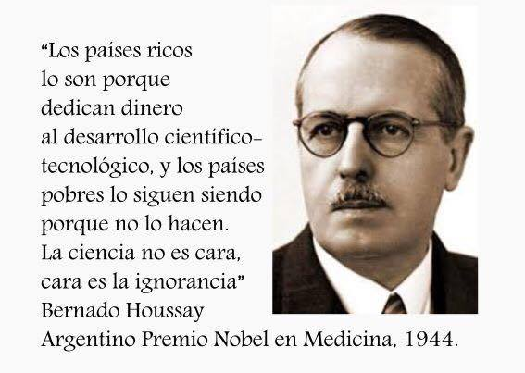As predicted in 2016 in the introduction to Éffictron, today we are pleased and proud that our work, Project Éffictron, is becoming not only "... a complex, computerized, sensor-actuated and highly mechanized product "If not also in a large scientific enterprise, where the exoskeleton, now the new Éffictron II, constitutes only a small part of the first.

In the course of the Space Apps Challenge 2017 we unite forces with another winning team of different mentions, Space Extractor, to be able to carry out this new entrepreneurship that such complexity cannot demand less. In addition, many students of different career have joined the team to give a great added value. It has been a year since the first NASA Space Apps Challenge in the city of Rosario, Argentina and the project chosen as a winner locally has not stopped growing. A few days ago, we spoke at the Argentine Congress of Aerospace Technology that took place in the city of Cordoba, in front of an amphitheater full of people and we got very good response from all the aerospace engineers who listened to us and our innovation was clearly highlighted by the organizers and participants. It was a very good experience and we have made a lot of new contacts that support PúlsAR Research and Development and its projects.

For all the above, we really really appreciate what you NASA and Space Apps organizer are doing, and did las year, for us and we own you all the good things are happening to pur team.

This year we feel more prepared to compete because, in this short time that we have been given to develop solutions, we have worked very hard to reach the very high standards of international competition, from last year to go delivering only a few sheets of paper, to what is today, a complete very competitive package that includes not only a presentation text rich in information and query sources but also, complete hardware, complete software; 3D designs and animations; Global and galactic impact, a video presentation of high quality and above all things love and dedication. We dream of being able to give Argentina the title of world champion in this magnificent branch of competition: Science itself, and to encourage and encourage so that all Argentinian young people, the future of the country, say yes to technology and innovation, a fundamental requirement to avoid stagnation and maximize the progress of a Nation.

You may notice that we have gone beyond what the challenge demands, and it is right. This is because we wanted to make the project more complex and fun and that is why, taking advantage of the **official Reddit**, where competitors were given the opportunity to ask what they wanted, we took advantage of it: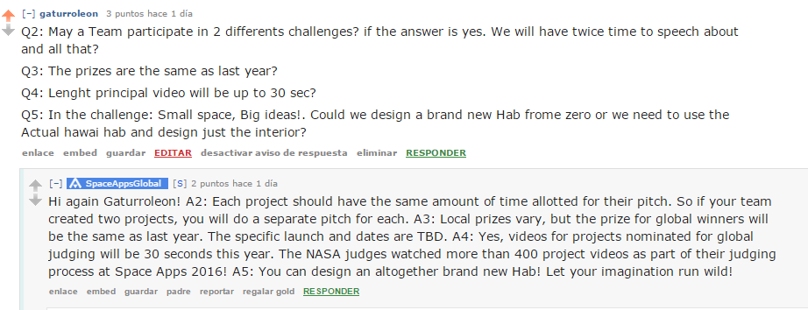

Question: On the challenge: "Small Space, Big ideas!" Could we design a brand new hab from zero or we need to use the actual Hawai hab and design just the interior?

Answer: You can design an altogether brand new Hab! Let your imagination run wild!

And that we did, we let our imagination run wild! and we not only designed the habitats, which we call HábitARs, but we designed the whole Colony where the selected ones will train almost as if they were already on the Planet Mars.

# *Dictionary of Project HábitAR*

**Training Center:** Representation of the **Colony** on the ground for training purposes. Physical location where the Trainees will live in Hawaii during the HábitAR project and where all the practice facilities, such as solar panels, the radioisotope generator or the fictitious communication antennas are located.

**Colony:** It is the true training center established in the planet Mars where the colonists, already trained, will live and carry out their main activities and will fulfill the purposes of the mission.

**Settler:** Astronaut appointed to travel to Planet Mars.

**HábitAR**: Sustainable structure where the astronauts / trainees will live

**Haven**: Foldable and inflatable structure that will serve as a temporary shelter until the HábitARs are ready to live. They also serve as emergency shelters in case the HábitAR project suffers an unforeseen complication.

**Trainee**: Person approved to spend a stay in Hawaii’s HI-SEAS during the Habitat Project

**MMBM:** sometimes referred as “**RevocAR”** Multipurpose Martian Builder Machine, a Mega Multipurpose robot, whose main function is build 3D structures knowns as **HábitARs.**

# *Category: Ideate and create.*

*Challenge: Small space, big idea.*

## *Description*

Create crew-friendly designs for a habitat and/or its multi-use furniture, to be used for isolation studies on Earth that are researching the environmental and human dimensions of life on another planet.

## *Situation:*

*HI-SEAS (Hawai’i Space Exploration Analog and Simulation) is a NASA-sponsored research program that is studying crew cohesion and selection for long-duration space missions. A crew of six lives in a habitat (the “hab”) that is a 1200 square-foot dome situated in a lava field on a site that is visually and geologically similar to Mars.*

*This small 1200 square-foot space has to serve many roles:*

*A laboratory room for crewmates to conduct personal research, providing isolation between lab materials (e.g. microbes) and regular crew activity*

*A clinical station to collect data on each of the crewmates*

*Personal rooms for sleeping*

*Bathrooms*

*A kitchen for cooking meals*

*A common area for eating, exercising, and socializing!*

*Your challenge is to design a layout for the hab that would accommodate all the activities that take place inside it. You may also, or instead design an energy- or space-saving piece of furniture or appliance to be used in the hab.*

*Think of the usability of your designs on Earth! Can they be applied to develop sustainable settlements in cities or villages?*

*This challenge addresses the following Sustainable Development Goals (SDGs), adopted by the United Nations General Assembly to engage all countries and all stakeholders in a collaborative partnership. The SDGs aim to build a better future for all people by achieving sustainable development in three dimensions – economic, social, and environmental – in the spirit of strengthened global solidarity:*

*Goal 11.1: By 2030, ensure access for all to adequate, safe and affordable housing and basic services and upgrade slums.*

*Goal 11.3: By 2030, enhance inclusive and sustainable urbanization and capacity for participatory, integrated and sustainable human settlement planning and management in all countries.*

## *Considerations:*

*When designing the hab layout:*

*Consider the internal dimensions of the habitat and constraints on the space use. For example, there need to be 6 bedrooms, a shower, a kitchen, and a common area for research and social activities.*

*Consider the human dimensions of the space. Crew relations are a very important aspect of life in the hab, and crewmates put effort into maintaining good relationships with each other. How would your layout help foster friendship, good communication, cooperation, and fun in the hab?*

*When designing a piece of furniture or appliance:*

*Consider the needs for items to be space-efficient, lightweight-but-sturdy, energy-saving, and multi-purpose. For example, you could design a desk that can be used as exercise equipment!*

*Consider ideas to support crew cohesion. As with the hab layout, design items that help foster friendship, good communication, cooperation, and fun!*

# General Planning.

## National instance

1. Write a report in Spanish ✓

2. Arrange the Layout of the colony with its well-detailed and referenced HábitARs and their different buildings in AutoCAD. Print it digitally in PDF with the normalized label and also in sheet in A3. ✓

3. Design and manufacture a simple model with mechanisms and lights for children. ✓

4. Description of the experiment in Hawaii.

5. Follow-up sheets for each judge at the time of exposure. ✓

6. Explain how this helps sustainably.

## International instance

1. English translation of the HabitAR project

2. Explanatory 30-second video

## Post-Preliminary draft Instance

1. Make the printer and assemble it in Hawaii

2. Construct the HabitARs with it using zone regolith

3. Evaluate how Trainees perform within the HabitARs

4. Study psychological and physiological effects of experience

## Project execution instance

1. Transport the necessary elements in advance to the destination planet

2. Include “The Beast” as part of the Payload

3. Moving a human colony

4. Plato a flag and formalize the colonization

5. Mount Heavens and Printers

6. Begin the construction of the HábitARs

# Introduction to project HábitAR

Our idea is to gradually and progressively make the extra-planetary housing technology of permanent inflatable domes, which have some disadvantages such as the expensive and late transfer from the earth to the destination planet; Its lack protection from solar radiation; His weakness heavy storms; Its poor thermal and acoustic insulation and its vulnerability to meteorite attacks, to a system that uses the natural resources of the planet in question, such as its regolith, in order to be able to become gradually independent of the earthly shippings and also to improve the aspects mentioned above and underlined , And we explain why:

Currently the transfer of material from Earth to Mars can cost tens of thousands of dollars per kilo (Prices published by Space X and other companies See image 1). If we plan to colonize the red planet in a meaningful way, with a large population and a vast amount of infrastructure, we must try to find a way to gradually become independent of the resources coming from our original planet.

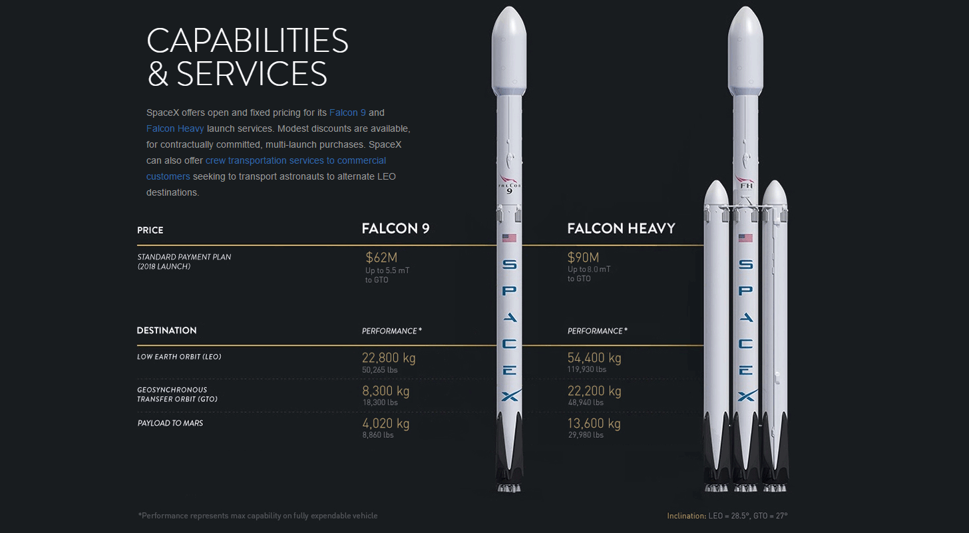  
Figure 1: Current SpaceX rates for cargo transport to Mars and nearby orbits.

If we remember the European settlers in America, who had already developed very advanced technologies of construction in their homeland, they also resigned their knowledge and techniques because they knew that the transfer from Europe of them to America would be very expensive and they began to build with indigenous resources. The first buildings were the rudimentary forts and wooden houses, material from trees and very abundant in America and Europe, from where it was taken ancient reference to finally develop and build the durable colonial buildings that today endure and we all know. See Figure 2.

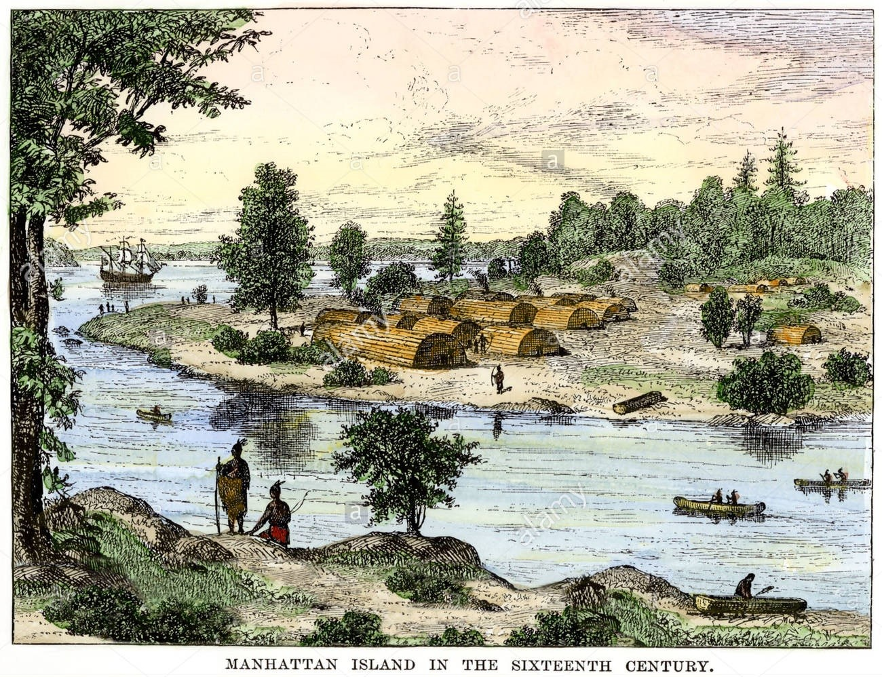  
Figure 2 Native and European people, together and living inside native-resources made Hábitars

In this new scenario, we must think in the same way, as the European settlers thought: Relate, for example, the Martian land with lands like the "Tierra colorada" (See figure 3) that is found in the north of our country, Argentina, which has minerals such as Limonite, very similar to Iron oxide III that is in the planet Mars, and experiment with it, extrapolating the results. Use the raw material of the colony along with rustic techniques to initiate the colonization until the transportation systems are so advanced that they allow the transfer of the necessary resources in an efficient way in some future, as it is today transatlantic sea and air transportation.

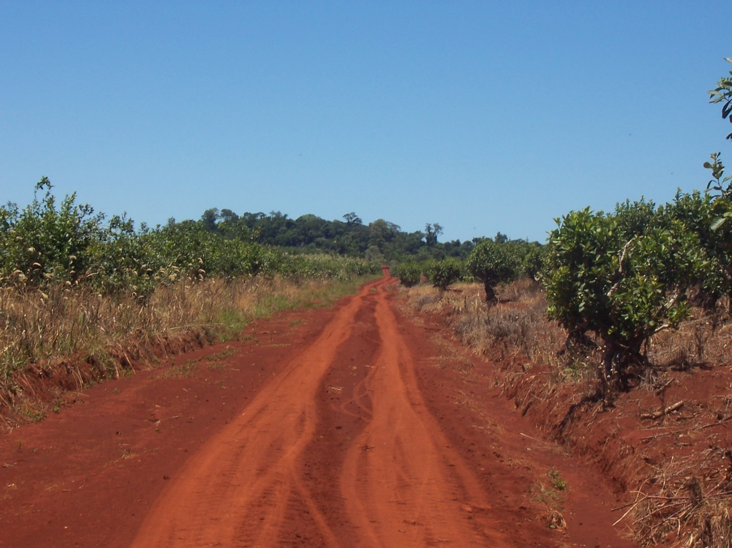  
Figure 3: Typical red dirt road in the province of Misiones, Argentina.

We take as an example the only current objective of the human species, the Planet Mars, as a reference to be based on this simulation. Our idea is, in simple words, to return to the archaic technologies of our civilization by building habitats of Martian regolith that, although we still do not know their specific characteristics, they do closely resemble terrestrial minerals as mentioned above.

This system will consist of a large multi-use machine with a big variety of technologies and capabilities like type 3D building techs, continuous track to carrie heavy weights and CNC selecting tools system, even a ground flatten system (figure 4), among others, that will be carried in a previous mission and later the crew will arrive in a subsequent mission so the workmanship can assemble the machine and put it to work. The simulation in Hawaii will be done in the same way. Those selected to train on the North American island will disassemble, assemble and put into operation this Multipurpose Martian Builder Machine **“MMBM”**, following strict protocols simulating been in mars, which will build their habitat with the red earth, so characteristic of that volcanic zone where this experiment is carried out. Below we detail our planning for the HábitAR mission.

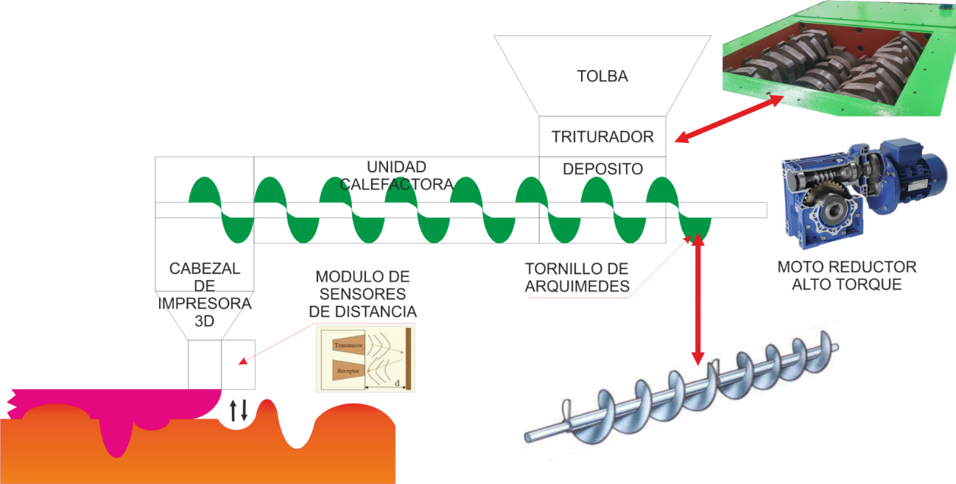  
Figure 4: This is our new Ground Flatten system, one of the capabilities of the **MMBM** Multipurpose Martian Builder Machine. It is useful to prepare and correct uneven ground and leave it ready to build on top of it.

Secondly, we are concerned with increasing protection against solar radiation through a habitat that not only increases the refraction of this threat, but also protects the levels of solar storms, thus preventing trainees from practicing this simulacrum and as a consequence settlers should not worry about this climatic factor.

The formation of these habitats of refractory material, iron minerals and volcanic rocks, all with magnetic properties, together with their thick double-purpose walls (Refracting radiation and internal pressure support) guarantee a perfect protection against these phenomena. On the other hand, trainees should practice in a darker module and not so friendly to the eye. However, we consider more important the protection of settlers than their emotional well-being, since it is assumed that people who travel are trained professionals and usually have military training and great psychological and physiological preparation.

Problematic about Perchlorates

The surface of Mars has been rich in perchlorates at least 3.5 billion years ago, so Mars has had a very oxidizing and very dry surface.

Perchlorates form between 0.5% and 1% of the soil of Mars known today are formed in the Martian soil from chlorides because of the action of ultraviolet light not blocked by the thin layer of ozone, Unlike what happens on Earth.

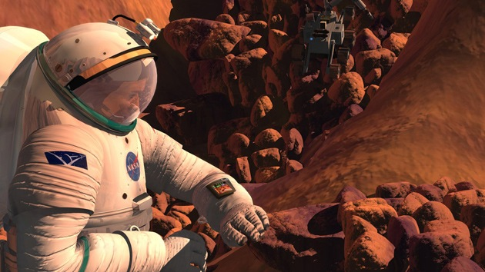On the one hand, the perchlorates of the Martian soil are harmful because it is a toxic material for both plants and humans as they cause hypothyroidism, a disease in the thyroid glands. It is considered a poison.

However it could be extremely useful for colonization of the planet and to help astronauts return to Earth.

Researchers at the American Institute for the Investigation of Extraterrestrial Intelligence SETI, led by the Spanish Alfonso Davila, have studied various aspects of the toxic substances present in the red planet, and have highlighted that they could be very useful for future flights to Mars.

On the one hand, scientists think the presence of perchlorates in the Martian soil is bad because they are toxic to plants, which means that human settlements on Mars could not use the soil of this planet for crops. In addition, the perchlorates absorbed by the body can inhibit the activity of the thyroid gland, which would lead to hypothyroidism. It is a very potent poison, and even a concentration as low as 0.5% is excessive since, under Mars conditions, with its frequent dust storms, this poison would inevitably accumulate in the folds of space suits, so the settlers of the planet would be under constant threat of intoxication.

On the other hand, the researchers point out, perchlorates are usable. Ammonium perchlorate is a strong oxidizing agent that is used as a component of explosives, and also in solid rocket fuel. This feature would allow the fuel to return to Earth in the long run to consist largely of its extraction from the Martian soil.

In addition, decomposition of perchlorate by heating will divide it into chlorine, nitrogen and water, and the value of the latter on Mars is unquestionable, not only by itself, but also because it can be decomposed into hydrogen and oxygen, and the latter will do much Future astronauts are lacking so they can breathe.

However, man cannot live in a constant process of industrialization, filtering the atmosphere and constantly removing the poisons from the soil because they will return because that is the nature of place. But there is a long-term solution: The environment in a natural and sustainable way of the atmosphere and the Martian soil, a slow process but that will over the years create a biosphere suitable for humans and their plants. Next, we explain

Sustainable ecosystem

If the human species plans to colonize the planet Mars, it will inexorably have to modify its environment, since, although it can industrialize the processes to create its proper environment, this is not sustainable and is totally unsuitable for its expansion.

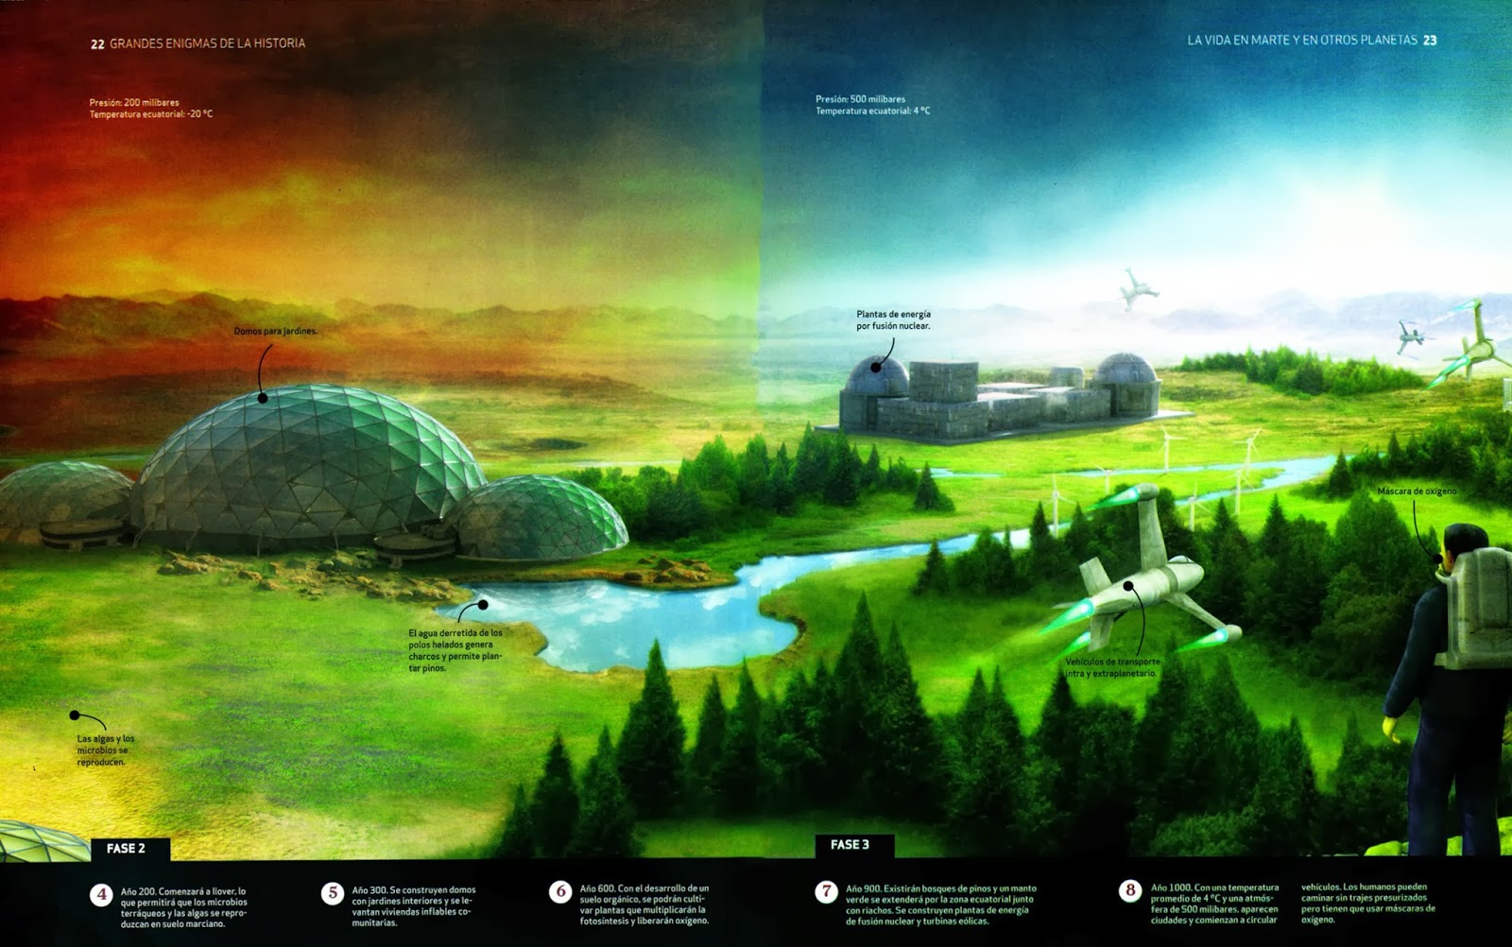

It is extremely important to discover how to raise animals and botany as it is a natural way of changing the environment without relying on a continuous process of filtering air, materials as explained above. Many plants are able to absorb heavy metals detrimental to health. The fall of leaves in the Martian land, animal’s waste and waste, both animal and human, applied to the Martian soil are becoming the same in a medium such that one day the Martian Biosphere can be considered, because it is already taken in a natural and sustainable way the conditions fit for life as we know it today. On the other hand genetics also plays a part: The genes of the species that can begin to live are making and adapting its genetic structure to the most apt for survival (Theory of evolution of Darwin).

We are not going to elaborate further on this issue because it is not a relevant one, but we must mention that the Trainees must now also train in animal husbandry and the intensive cultivation of different plant species, simulating this very important stage that is the Formation of a Martian Biosphere.

# Mission plan & simulation

At the beginning of the experiment, the selected crew for the HábitAR mission will have to arrive at the site with the same tools that will be given to them in the real mission that will be carried out on Mars in the year 2033. They will live in temporary, folding and inflatable habitats which we have called "Havens" until the first sustainable habitat, called by us "HábitAR" has been finalized, carrying out the move.

Upon arrival, they will use one of the Havens for the sustainable production of botany.

Subsequently will continue the sustainable manufacture of HábitARs waiting for the arrival of more astronauts and / or the reproduction of them in the new planet. The simulation in Hawaii will be very similar: There may arrive more Trainees to the Training Center pretending to be new settlers when the printer has made more HábitARs.

All other facilities listed below must also be assembled and / or manufactured at the Training Center for Trainees to practice and learn to use and maintain. All facilities will also be used in order to be able to experience possible faults that can only be detected through experimentation.

Description and characteristics of Training Center and future Colony

The Colony constitutes the whole complex and area where the settlers will inhabit and carry out their main activities. As expected, for a few years these conditions will be simulated in Hawaii at a Training Center. Both have the same characteristics so that the following are the components that make up both, the colony and the Training Center, and that will be necessary for the sustainability of the same.

1. Living Place
   1. Havens (Temporary)
   2. **Main HábitAR**
   3. Rover’s Haven
2. Energetic Infrastructure
   1. Nuclear power station (main energy source)
   2. Solar panels zone (Back up energy source)
3. Tangible Resources Production
   1. Mega Lava oven
   2. Damp Regolith extraction station
   3. Blast furnace (Future Project)
4. MMBM (Multipurpose Martian Builder Machine)
   1. Method 1: Casting of Martian rock by microwaves techniques
   2. Method 2: Elaboration with clay extracted from the soil
5. Orchard
6. Satellite communication structure

# 1.- Living Place

## 1 a.- Havens: Temporary shelters

HAVENs (Habitats Valuables for Entrepreneurs) are temporary dwelling modules of inflatable dome type that will have some design of poor duration that does not concern us, but will be enough to keep the settlers living in a relatively comfortable way during the construction phase of the first sustainable HábitARs or, very importantly, if construction methods fail for some reason and the mission

must be aborted. We are in contact with the Engineer Dr. Pablo de León, whose design we will use as reference for this stage. We will not detail these modules so precisely because our main project is the sustainable and mass construction of the HábitARs, which will allow to accelerate the process of Martian colonization.

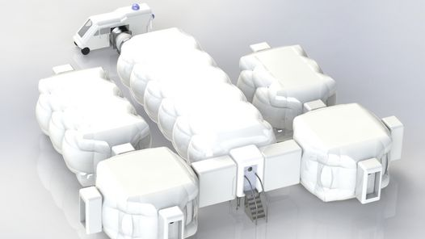

Image of an inflatable dome type HAVEN, developed by Ing. Dr. Pablo de León.

Once the HábitARs have been constructed and tested and when a high degree of certainty that they can allow human life is reached, Havens will be discarded, either by expiration or by the simple act of attrition produced by nature, and all settlers will pass to reside permanently in the habitats of Martian Regolith.

In principle, it is stipulated that two Havens be armed:

### HAVEN-Alpha

It will be the habitation for the settlers' stay. It has a dining room, rooms of bunk beds arranged to two astronauts on adjacent walls and inside these second there are retractable walls bellows type that allow to fold and form a common room in the middle for recreation and / or dining. All beds have a retractable roller shutter up Roll-up type black-out style that allow for greater privacy and less luminescence for rest. It will also have a small bath and shower with continuous water filtration systems as used in the International Space Station (hereinafter referred to as ISS) for water saving issues and availability of space. In addition, it will have an area dedicated to the research laboratory.

### HAVEN-Beta

Room adjacent to the HAVEN-A for use exclusively for greenhouse for the cultivation of several plants that will be used for materials and in the future as a power source. Nowadays there are several experiments, both in the ISS and in several places of the world like private or state laboratories, universities, government agencies and interested companies and even World Disney World with its attraction of hydroponics of plant growth in the desert, dealing With different crops so that these plantations offer greater yield and that are sustainable in abnormal soils. All this is largely thanks to the manipulation of various factors that alter the state of plants, such as light, genes or nutrients, among others. This habitat may be isolated from HAVEN-A or, in the most propitious case, connected to it by a bridge similar to the bellows-type aisle such as those seen at airports when boarding an international aircraft.

## 1 b.- Main HábitAR

The structure of the different HabitARs, the denomination we have chosen for our designs, will be a semi-cylinder of unique design, with ends of ball rooms that will serve as a compression / decompression room, with direct access to the Rovers Refuge. This particular form allows adequate pressurization necessary for human life independent of a space suit, which is around an atmosphere (101325 Pascals). For this design we have been based on a typical CNG tank and we have adapted it to form a more architectural shape of housing that still allows to withstand high pressures. The reader may think that an atmosphere is not an excessive pressure because it is the one that all our buildings on earth are enduring; However it must take into account that there is a quasi-vacuum on the outside of the structure for the case of Mars that does not counteract the internal pressure and this causes that this internal tension becomes relatively much more intense and that is why the structure must count With a very particular shape and thickness that we have specially calculated and detailed later to do the work that here on earth makes the atmosphere and prevent the habitat from exploding.

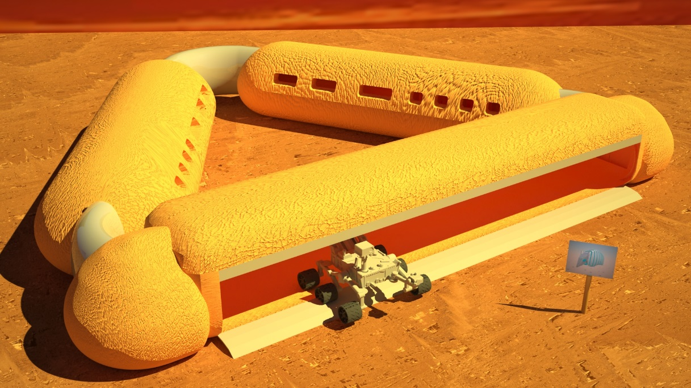

Figure 1 3D design of the Main HábitAR, mainly made from Martian Regolith

The first refuge will be the main Habitat and will have the 6 rooms, the pantry, kitchen and a dining room. See Figure 2:

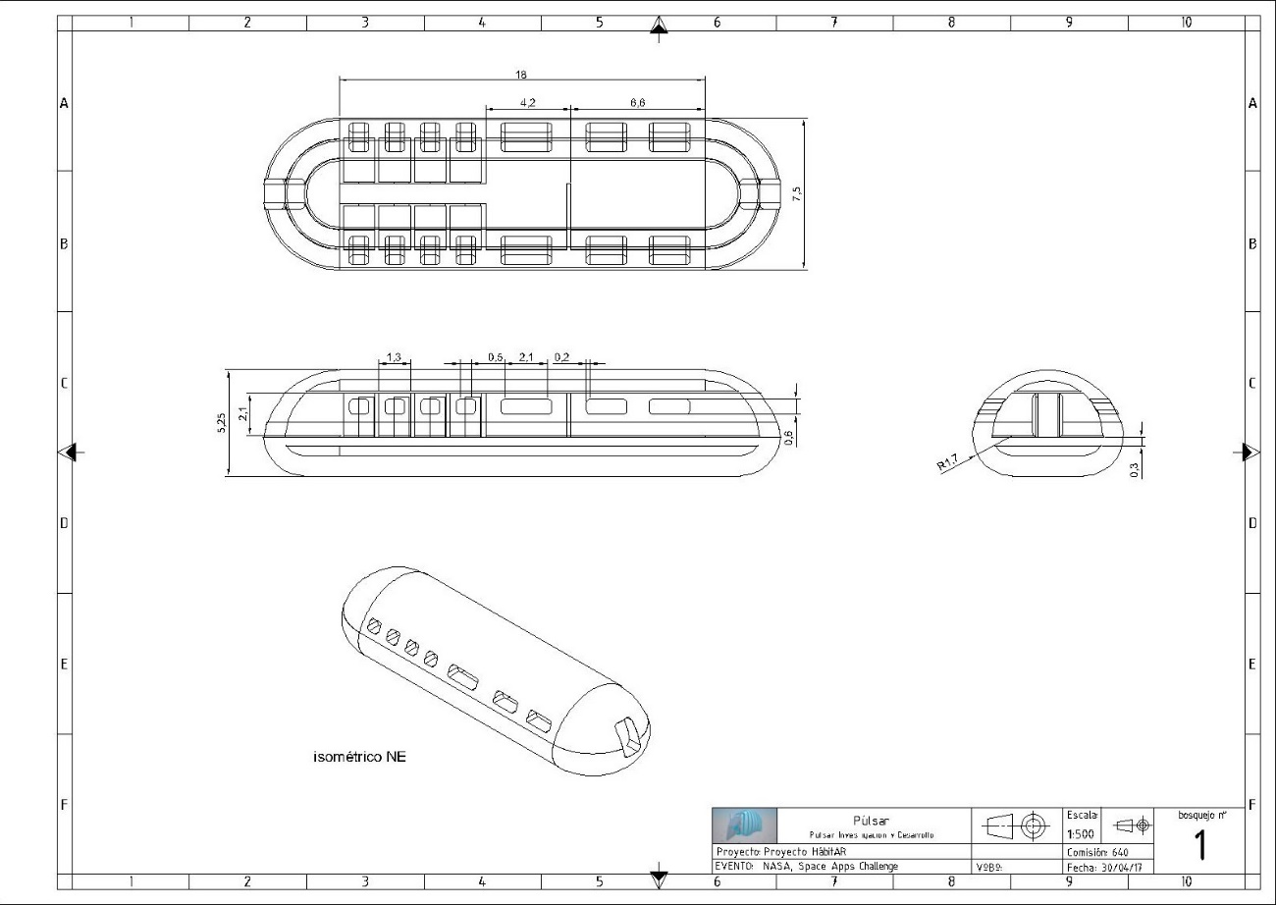

Figure 2 Layout of lef HábitAR

**Main HábitAR.**

The second HábitAR will include the recreation room, laboratory and work area room.

Another Habitat connected internally with the main will include the laboratory and the garden.

The rooms will be very simplistic, so that the astronauts do not spend much time in it and go to the commons, improving the sociability. Next, we have developed the simulation to know the shape and thickness suitable for our HábitARs. Although we do not know with certainty what the Martian surface or its rocks actually are, we can extrapolate results obtained in the earth using similar materials, as they do in HI-SEAS, Hawaii, and use as reference the mechanical properties of the Red clay.

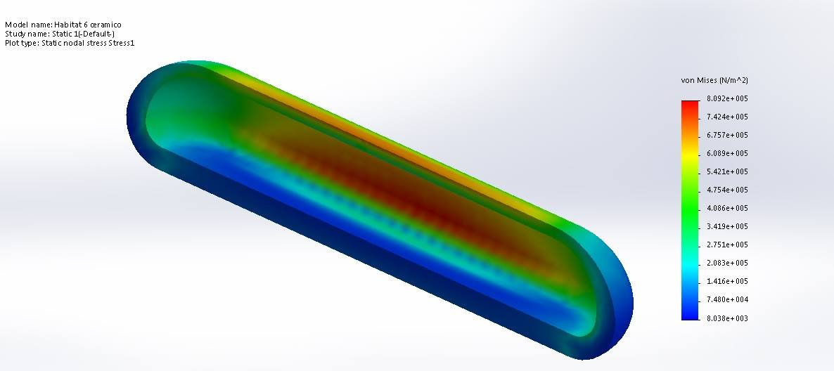

In the case that we use the option of the rock smelting, which is more similar to the limonite and assimilated with the smelter, we obtained the following results: First we need much less material for the walls and ceiling, that is, a Much lower thickness. However, the process of manufacturing the raw material requires a greater investment in capital and a much more resistant 3D printer, made of tungsten carbide to withstand high temperatures.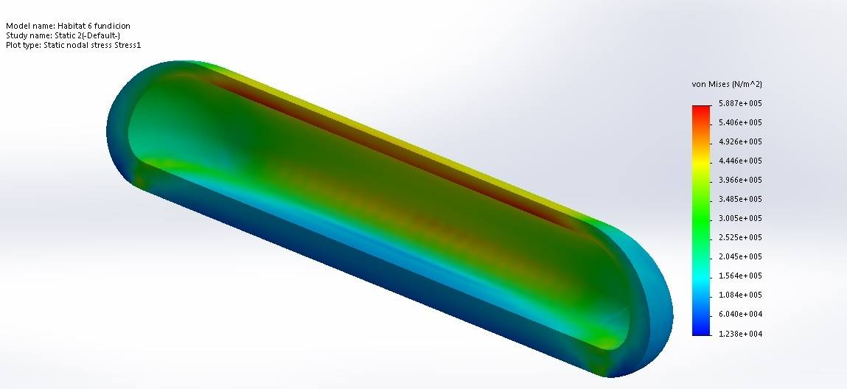

In conclusion, we recommend the technique of manufacture with deep Martian clay that, although it requires more material due to the thickness of the walls, in Mars this one is practically unlimited.

However, we develop both possibilities so that they are seated in the report.

## 1 c.- Rover’s Haven

A kind of garage suitable for safeguarding the currently developed Martian vehicles and those that will devolve in the years that remain until the mission, both manned and unmanned View Figure 3. This refuge provides mainly the same advantages as a family garage here on earth does: to be able to get off the vehicle and enter the hab in the event of storms without having to go through the outdoor as there is a connection from the shelter to the compression rooms Of the Habitares.

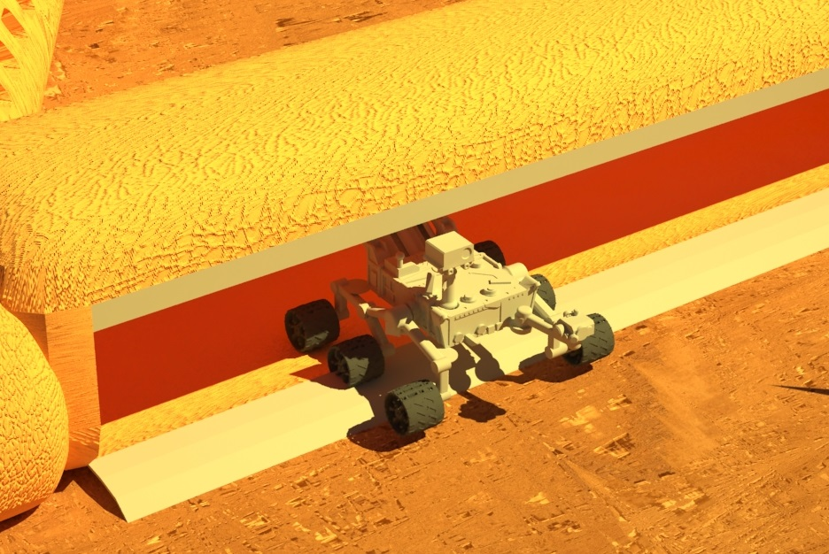

Figure 3 Rover's Haven

# 2.- Energy infrastructure

Our colony will use 2 types of energy sources: A main source of energy based on nuclear RTG type and a second one with purpose of contingency, support and diversity, which is the solar energy.

### 2 a.- Main source: Nuclear Energy based on RTG

A Radioisotope thermoelectric generator (RTG) is a simple electric generator that gets its energy from the one released by the disintegration of certain radioactive elements. In this device, the heat released by the disintegration of the radioactive material is converted into electrical energy directly by the use of a series of thermocouples, which convert the heat into electricity due to the thermoelectric effect in the so-called radioisotope heat unit. RTGs can be considered a type of battery and have been used in satellites, unmanned space probes and remote installations that have no other source of electrical or heat source. RTG devices are characterized by being able to dispense with maintenance and also by producing high power for very long periods, so that astronauts could occupy their minds in other activities of the mission and only deal with energy when replacing the raw material.

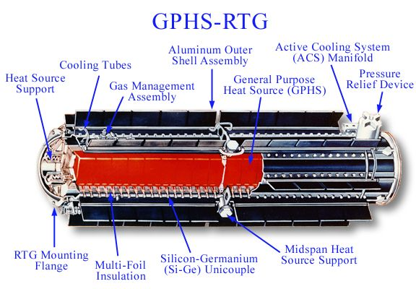

Figure 4 Diagram of an RTG used on the Cassini probe

This energy would only consume a very small part of inputs from the earth: uranium dioxide pellets, which weigh about 5 grams and can last for months. As a reference a central supply for 200,000 families uses 130 kg of Uranium Dioxide per day, so the initial small crew will not need more than two kilograms per year; In monetary terms, less than half a million dollars a year in transport costs which, although it may seem a high figure, is very small in terms of interplanetary travel. The waste, being such a small amount will not require more attention and will be discarded away from the bases where very little heat emanated during millennia until its final stabilization. One use that can be given to nuclear waste may be that they are used as heating small environments, but only in really necessary circumstances since the benefit is not so great in contrast to the high risk that would imply having radioactive material near the settlers.

**An interesting fact about nuclear energy is that a nuclear installation of the same surface as a solar produces 500 times more energy.**

### 2 b.- Secondary and contingency source: Photovoltaic Solar Energy

Photovoltaic Solar Energy, a little more efficient than the one obtained on the planet Earth on the one hand since the Martian atmosphere does not filter as much radiation, but extremely inefficient on the other, on the side that mars, on average, is 80 Million of kilometers farther from the sun than Earth, drastically decreasing the performance of solar panels. Another problem with this technology is the intense wear it will suffer from the strong Martian storms of dust and stones that would eat protective crystals that would reduce its normal useful life of 15 years drastically

# 3.- Tangible Resource Production

Thanks to filtering and recovery technologies, resources can be reused with a recovery level of up to 93% such as the water.

However, the settlers must, in addition to recycling their resources, obtain new ones from the colonized planet, since the supply orders will not be very frequent due to the great distance that exists between the planets. These resources will mainly be water, the raw material of the construction and in the future the possible extraction and production of iron.

Part of the nuclear energy transformed into electrical energy will be used in furnaces to melt the rock and to obtain a new chemical compound that serves as raw material for the construction of the Habitares and to use a 3D printer of alloy of carbide of tungsten (or carbide of Wolfram) to withstand heat, since its melting point is 2870 ° C.

There is a problem with regard to the Martian land and is that it has different perchlorates, substances toxic to humans. However, by a chemical decomposition consisting of the application of thermal energy it can be decomposed into water, nitrogen and chlorine. Then by distillation pure water is obtained for different uses.

# 4.- MMBM (MULTIPURPOSE MARTIAN BUILDER MACHINE)

The MMBM (Multipurpose Martian Builder Machine) is our most innovative element in the HabitAR Project. It represents a new paradigm when it comes to thinking about the Martian colonization of the human species and offers possibilities of extraordinary cost savings.

Based on new developments for the fabrication of structures here on Earth, such as those shown in Figure 3, we have taken these ideas to develop a method that can print similarly, but using the resources of the Red Planet.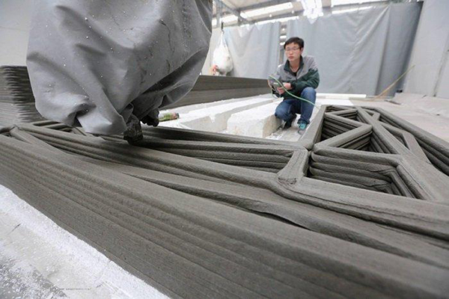

Figure 5 New way to build structurs with 3D technolgy

In order to save capital, we have thought that, instead of designing a land collection station, another ore smelting station, etc., and thanks to the progress that will be made in the years when the missions to Mars are launched, Develop an autonomous robot that through artificial intelligence and Learning Machine techniques, can serve as a multipurpose vehicle. Its functions will mainly be the 3D printer with Martian regolith, but also will have mobility by continuous track; hoppers for the collection of the necessary materials, selective type heads such as those used by CNC equipment, which will allow you to use the same arm both for the extraction of materials and for printing of the HábitARs.

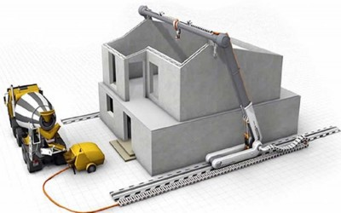

Figure 6 ilustration of a 3D technology building

## Martian construction materials

### 4 a.- Method 1: Casting of Martian rock by microwaves techniques

Microwave is called the electromagnetic waves; Generally between 300 MHz and 30 GHz, which involves a period of oscillation of 3 ns (3 × 10-9 s) at 33 ps (33 × 10-12 s) and a wavelength in the range of 1 to 10 mm . Other definitions, for example those of the IEC 60050 and IEEE 100 standards, place their frequency range between 1 GHz and 300 GHz, ie wavelengths between 30 centimeters and 1 millimeter.

The range of microwaves is included in the radio frequency bands, specifically in the ultra-high frequency range of 0.3-3 GHz, SHF (super-high frequency) 3-30 GHz and EHF (extremely-high frequency) 30-300 GHz. Other radio frequency bands include lower frequency and longer wavelengths than microwaves. The microwaves of greater frequency and smaller wavelength (in the order of millimeters) are denominated millimeter waves.

Microwaves can be generated in several ways, generally divided into two categories:

- Solid-state devices and devices based on vacuum tubes. Microwave solid state devices are based on silicon or gallium arsenide semiconductors, and include field-effect transistors (FET), bipolar junction transistors (BJT), Gunn diodes and IMPATT diodes. Special versions of standard transistors have been developed for high speeds that are commonly used in microwave applications. Vacuum tube-based devices operate taking into account the ballistic motion of an electron in a vacuum under the influence of electric or magnetic fields, including magnetron, klistron, TWT and gyrotron

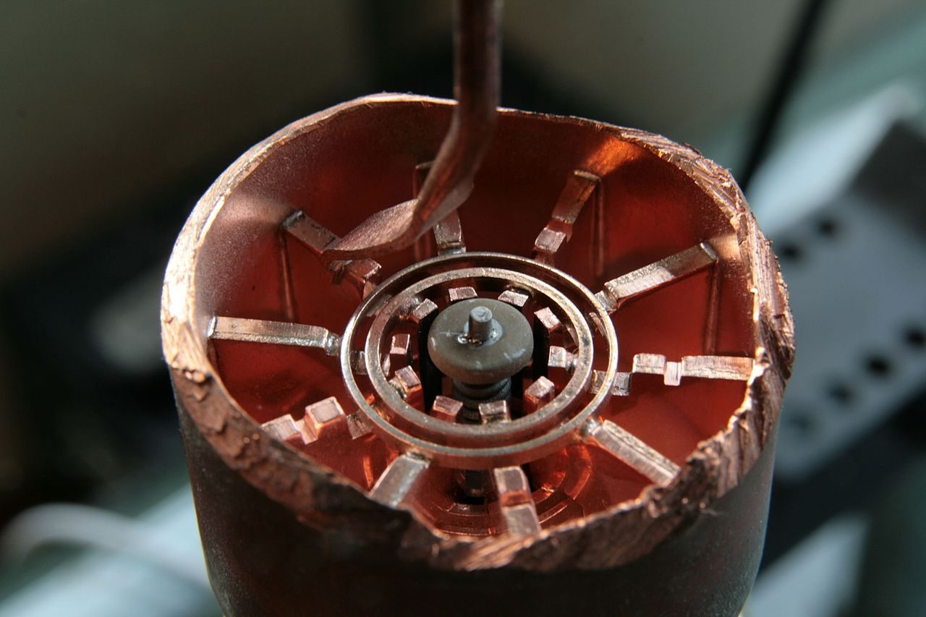

Figure 7 Cutaway view inside a cavity magnetron as used in a microwave oven

For this purpose, the microwave emitting device must be designed in such a way as to have the same configuration as a microwave oven, which uses a magnetron to produce waves at a frequency of approximately 2.45 GHz. These waves vibrate or rotate The molecules of water, which generates heat.

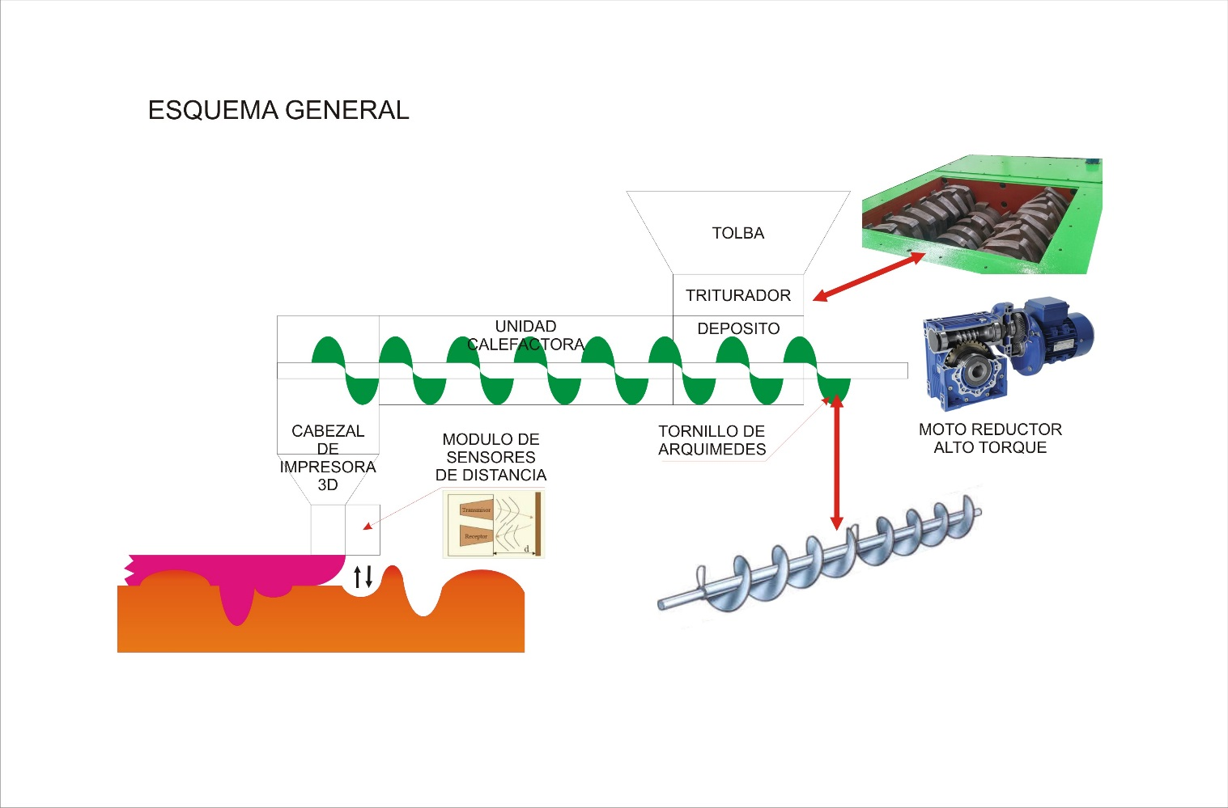

Because most foods contain a significant percentage of water, they can be easily cooked in this way. The same is intended to heat the molten rock, which contains a good part of water, at a temperature such that the substrate acquires a consistency of moldable paste.

The MMBM also has the ability to flatten the Martian soil to increase the stability of the structure and allow to build on uneven terrain.

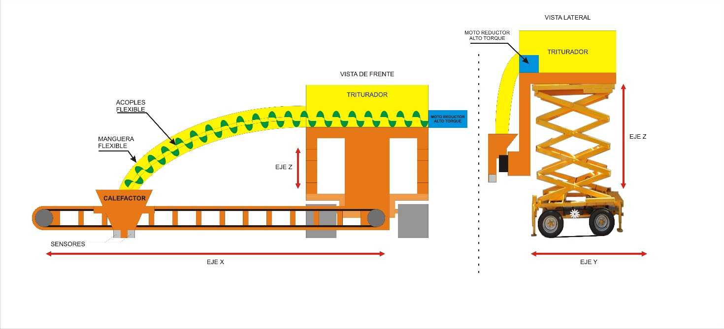

Advantage:

- does not require a lot of energy

- according to the design can be portable and mobile, facilitating the adaptation to the MMBM

Disadvantages:

- It is not scientifically proven that using ultra high frequencies can melt the rock, especially since there is not much information about it

- The fact that it requires high temperatures requires a very careful handling of the material, which can be detrimental to the mission

- The 3D printer, in this case, must be adapted to withstand high temperatures, close to the melting point. Already the fact that you have to work with a printer transport system purely made of tungsten carbide.

Although there is not much data on how much the Martian rock melts, which makes this method to be carried out for experimentation, here is another more practical alternative but that requires more material.

### 4 b.- Method 2: Elaboration with clay extracted from the soil

Just below the Martian soil, there is soil containing a good percentage of moisture, enough to create clay from it. This method is not very different from that used in masonry, except that on Mars must undergo a previous process of disinfection

Advantage:

- Method that does not require high temperatures

- It is more feasible to elaborate it

- It is easier to manipulate

- The 3D printer does not require adjustments with respect to temperature

Disadvantages:

- Requires to use a lot of material to achieve a resistance to the internal pressure of the Habitares.

- Requires a good amount of water, consequently it will not be suitable for consumption or for crops

## interior HábitARs design

## Atomizer Shower

This innovative showerhead saves space in the HábitAR and its atomizing system is also economizing on the water care aspect. The same can be seen in figure 5. Its design consists of a telescopic structure that at rest is located on the roof of the bathroom. When we use that telescope, it unfolds over the user and surrounds it with its hoops attached to a transparent membrane that will shield the atomization of the water and also provide vision, preventing claustrophobia and allowing the entrance of natural light of the environment.

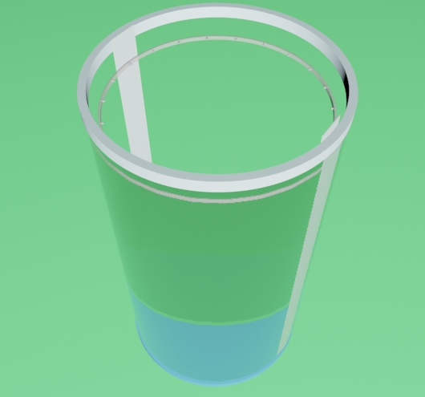

Figure 8 Atomizer Shower 3D concept

Economizing a resource as valuable as water requires unprecedented engineering and for this it requires very new and never seen designs. In this case, we think of it as an atomizer (or spray) system, that is, that the shower expels microdrops in the form of dew, at a high pressure such that it splashes the body with considerable force.

At first, it was thought of a series of columnar rings, one arranged on top of the other, either together or separated in an equispaced form.

This changed with a new proposal, which would allow us to save water and material to build it. The concept is that of a single ring, which is lowered and raised by means of 2 steel pillars that support it, whose dimensions are 1.20m in internal diameter and 1.33m in outer diameter, by 8cm high. Made of a material to be determined. On the inner wall of the ring are arranged a series of small peaks with holes pointing to the center of the ring (understood as the astronaut). These holes expel soap solution of water and glycerin (being neutral and less annoying to the body, used in baths for small children) in an atomized form, that go down from the containers installed superiorly and through a flexible silicone pipes, arrive at a small atomizer powered by a computer-controlled electric motor.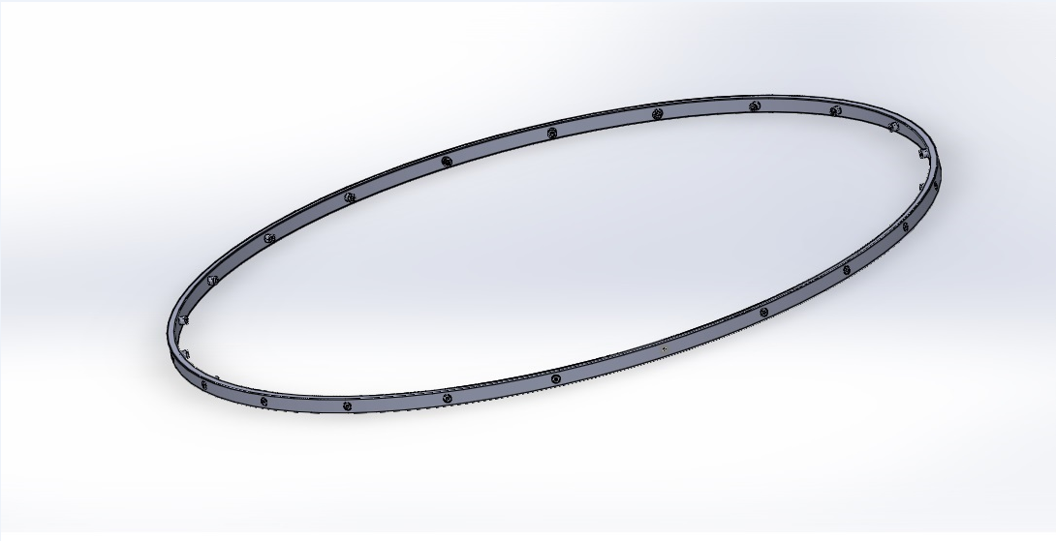

Figure 9 Atomizer Shower Ring 3D Model

At the moment of shower, initially the ring drags a tubular curtain and opaque plastic and secures it on the base, to avoid loss of water and steam for later recycling.

In order to be multipurpose, a fan with a resistance has been adapted to let jets of cold or hot air, as the case may be, and allow the person to dry, so that the whole cleaning procedure can be carried out in a very Fast.

In HabitAR there will be only 1 spray shower.

Foldable and / or Sliding Walls

Its main function is to increase housing space occasionally. It is also useful in social aspects such as allowing 2 rooms to convert 2 so that 2 settlers can spend the night together for a matter of affinity.

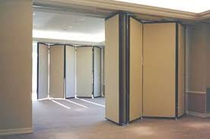

Figure 10 View of a folding and retractable wall.

Although these walls are not part of the sustainable colonization plan since their materials must be brought from Earth, they can be used within the first HábitARs since the plan indicates that the transition to the independence of the terrestrial resources will be gradual.

The figure 8 shows that inside the structure there are 6 walls near one end of the Habitat, these walls make up the rooms of the astronauts. It is provided that the first 4 walls, are foldable and / or retractable.

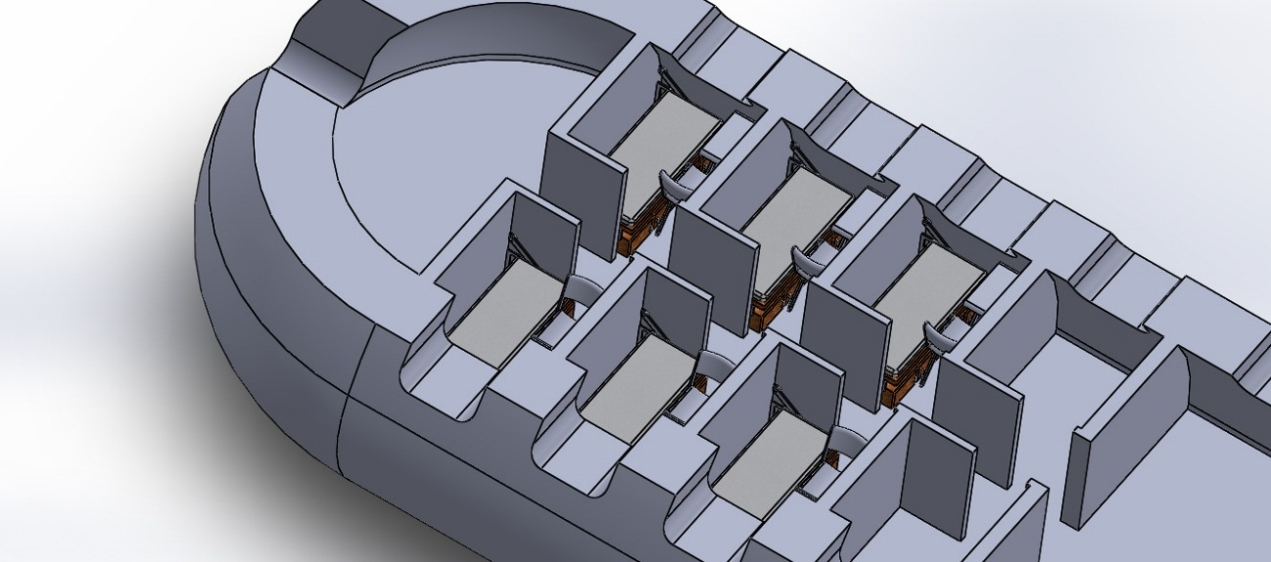

Figure 11 Isometric view of a cut of the Habitar, in the section rooms section

As informative, it is important to note that the walls were also thought to be a textile fabric type awning to be retractable as a curtain but in the end this idea was discarded as it does not provide sufficient privacy among the inhabitants, and would also require a support for the winding, which would be an unnecessary addition.

By increasing the habitat space of the HábitAR, this common room is instantly converted into a space that can be used as part of the dining room, or in a nursing room or, in the most probable case, in a space for physical activity or using an exoskeleton device better known as ÉFFICTRON (our 2016 Space apps Project), or devices such as ARED, CERVIS or COLBERT, machines that can work in reduced environments and regardless of gravity.

# Multitask furnitures

## Wordrobe-bed

This concept of bed cupboard is specially designed to be used in our HábitARs, maximizing the spaces used. See Figure 12.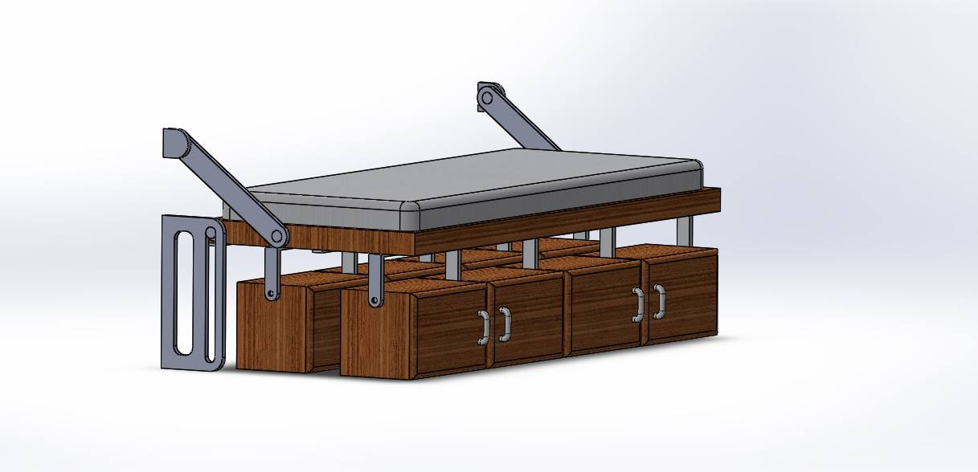

Figure 12 The W-Bed in sleep position

The same has a system of batting that allows it to be directed vertically against a wall when it is not used and, at the same time and in a very novel way, exposes a series of compartments where the Trainees can store their belongings. The front drawers are useful for objects of frequent use since they do not need to fold the bed to be able to access them. See Figure 13 & 14.

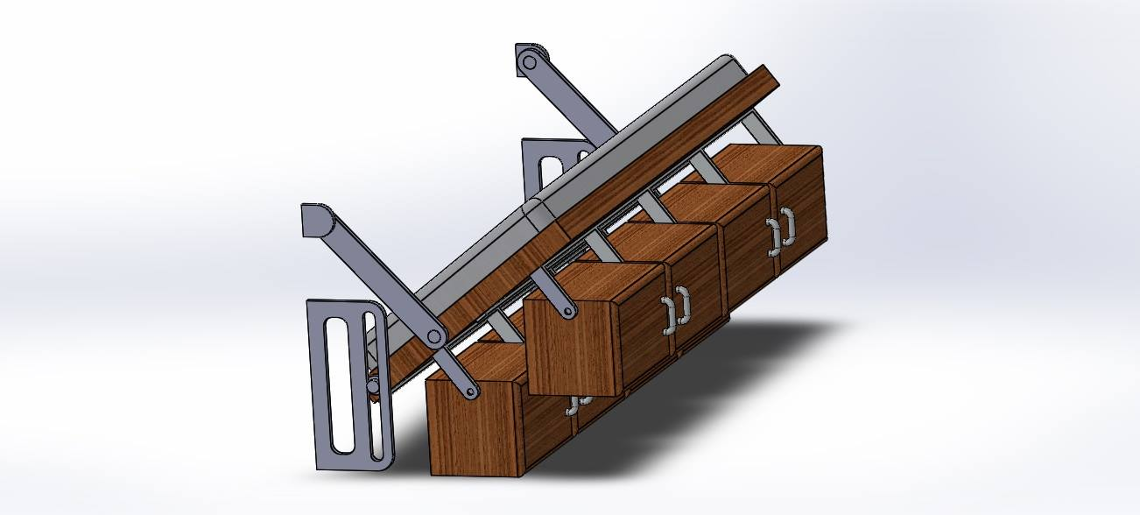

Figure 13 W-bed being transformed

The intended destination for the rear compartments is for other items that do not require use during sleep, such as other season clothes or footwear (Note that the experiments in Hawaii last 8 months, so they will have objects from another Season that will not be used and should be stored somewhere)

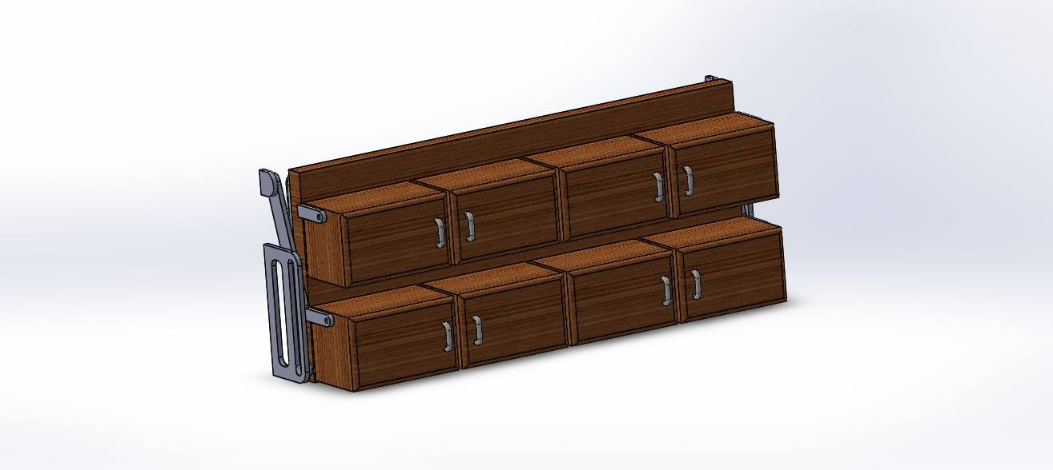

Figure 14 W-bed in the full Wardrobe mode

It is thought to be assembled like the furniture that is marketed in boxes and with few tools, like screwdrivers and screws that allow subjection, very used in these previously named furniture.

## Folding chair

This chair is not as novel as the previous furniture, but perfectly fulfills the same function. Their foldable shape allows them to be stacked and take up very little space. The following figure shows its design. See figure 15.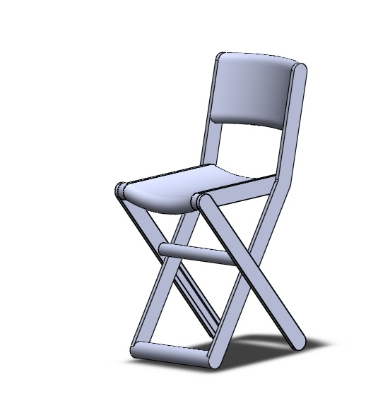

Figure 15 Our design of the Folding Chair specialy for HábitAR Project

## Fantastic Desktop

This desk follows the parameters of the chair and fits perfectly in the HábitAR, occupying very little space. See figure 13.

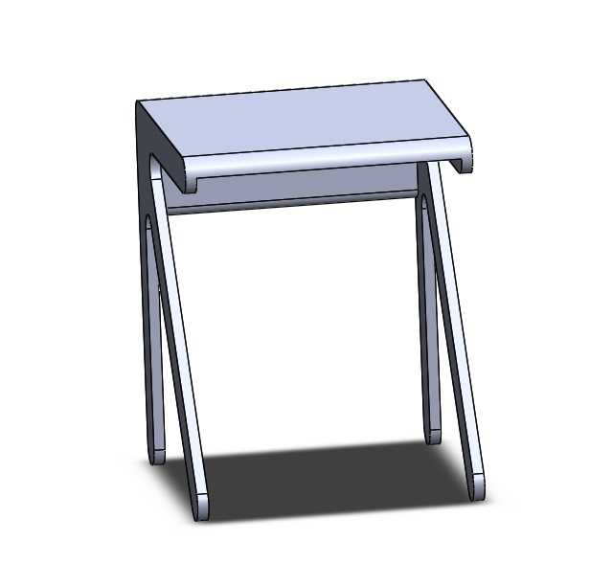

Figure 16 Figure 13 Fantastic Desk for the Bedrooms

There will be one per room.

## Kitchen Counter

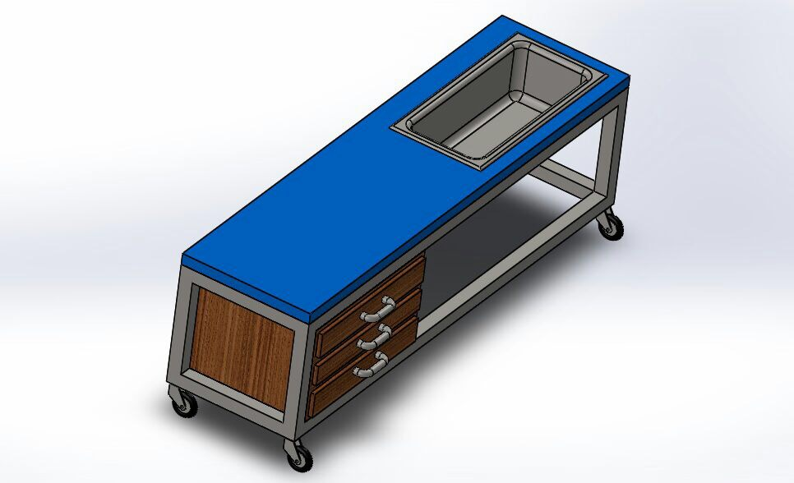

## Electric Kitchen with wheels

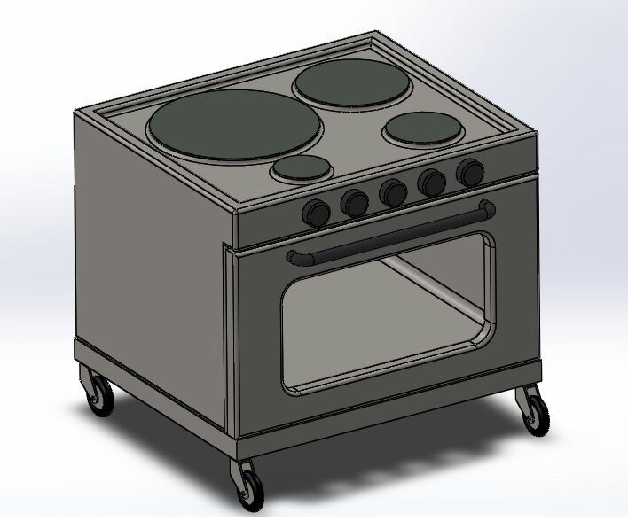

# Future project ideas.

## Space elevator:

Es una base en órbita donde se reciben suministros, está vinculada al planeta mediante un cable hecho con nanotubos de carbono (u otro material lo suficientemente resistente) por el que sube y baja un ascensor para acercar los suministros al planeta. Este es mucho más factible en Marte que en la tierra debido a la más baja gravedad y tamaño lo que supone menos resistencia y menos tramo de cable (elemento principal necesario para llevar a cabo la idea que ya se planteó pensando en la tierra). Al no tener que amartizar las cargas se reduce el costo enormemente de los cohetes que no necesitan hacer descenso y ascenso desde marte. También al tener un punto de anclaje al planeta, funciona como puerto y se le pueden ir acoplando módulos y hacer una ISS marciana aunque sería Interplanetary Space Station.

## Possible discovery of sulfur

Si en misiones posteriores se descubriese azufre en la superficie de marte o en zonas accesibles

## Iron and steel industry

Otro proyecto a futuro que los colonos pueden realizar es obtener hierro dulce y acero en base a la gran cantidad de óxido de hierro presente en el planeta Marte implementando siderurgia para aprovechar ese material y utilizarlo en la construcción. El acero es muy útil para hacer esqueletos de hormigón armado, que le brindan a la concreta resistencia a la tracción, pudiendo hacer así refugios más resistentes. El Alto horno es un proyecto en principio viable debido a que en Marte abunde material refractario, facilitando la obtención de recursos para la construcción de este primero.

# Resource and bibliography

## NASA resources

Centro de experimentación en Hawái <https://hi-seas.org/>

Características del Hab actual de Hawái <https://hi-seas.org/?p=1278>

Desafío <https://2017.spaceappschallenge.org/challenges/ideate-and-create/small-spaces-big-ideas/details>

3D rover design https://nasa3d.arc.nasa.gov/detail/mars-rover-curiosity

## Our own resources

### Planet Mars:

Documental sobre marte: <https://youtu.be/VvmKgu2pXyk>Comparación tierra marte <https://es.slideshare.net/hfaa62/comparando-suelos-de-la-tierrt-m>

Chimeneas con circulación de fluídos en Marte <https://www.scientificamerican.com/espanol/noticias/curiosity-descubre-chimeneas-por-las-que-circulaban-fluidos-en-marte/>

Elaboración de suelos fértiles en Marte <http://blogthinkbig.com/como-de-fertil-y-cultivable-es-el-suelo-de-marte/>

Colonización de Marte [https://es.wikipedia.org/wiki/Colonizaci%C3%B3n_de_Marte#Radiaci.C3.B3n](https://es.wikipedia.org/wiki/Colonizaci%C3%B3n_de_Marte)

Sobre Marte <https://es.wikipedia.org/wiki/Marte_(planeta)>

Atmósfera de Marte <https://es.wikipedia.org/wiki/Atm%C3%B3sfera_de_Marte>

Extracción de agua en marte <http://www.mars-one.com/faq/health-and-ethics/will-the-astronauts-have-enough-water-food-and-oxygen>

Todo sobre Marte por la NASA <https://mars.nasa.gov/>

Posibilidades de perclorato <https://actualidad.rt.com/ciencias/view/98239-perclorato-marte-combustible>

Perclorato en Marte <https://observatori.uv.es/los-problemas-del-perclorato-en-la-colonizacion-de-marte/>

Más Hallazgos de Perclorato <https://culturag34c.wordpress.com/2016/10/27/hallazgo-de-percloratos-en-marte/>

### 3D impression for Mars:

Impresión con Azufre <https://www.youtube.com/watch?v=v4IbS42D8jk>

Desafío habitáculos 3D <https://www.youtube.com/watch?v=KKPtMjUEnX8>

Concurso sobre hábitat marte <https://www.nasa.gov/3DPHab/>

Charla sobre herramientas en marte en 3D <https://www.youtube.com/watch?v=sDfh_IKFGz0>

### Mars rockets

Nave orión <https://es.wikipedia.org/wiki/Ori%C3%B3n_(nave_espacial>)

Lanzador Ares <https://es.wikipedia.org/wiki/Ares_I>

Proyecto Constelación <https://es.wikipedia.org/wiki/Proyecto_Constelaci%C3%B3n>

### Materials and constructions of clay:

Habitats temporales o HAVEN: <http://www.latam.discovery.com/ciencia/imagenes/habitats-impresos-en-3d-para-la-vida-en-marte/>

Documental sobre construcciones de barro <https://www.youtube.com/watch?v=5BxcRVdWaRc>

Tierra colorada <https://es.wikipedia.org/wiki/Tierra_colorada>

Arcilla <https://es.wikipedia.org/wiki/Arcilla>

Mineral de la tierra colorada <https://es.wikipedia.org/wiki/Laterita>

Mineral que se asemeja a la tierra de marte <https://es.wikipedia.org/wiki/Limonita>

Funcionamiento de altos hornos [https://docs.google.com/presentation/d/1CdUGk5-aclM-nVuT81P5cmbv0zUzGu8c4hTfJh0N_ts/embed#slide=id.i34](https://docs.google.com/presentation/d/1CdUGk5-aclM-nVuT81P5cmbv0zUzGu8c4hTfJh0N_ts/embed)

<https://es.wikipedia.org/wiki/Alto_horno>

Fábrica movil de ladrillos <https://www.facebook.com/interestingengineeringvideos/videos/1976955972527456/?hc_ref=NEWSFEED>

Microondas <https://es.wikipedia.org/wiki/Microondas>

Revestimientos <https://ovacen.com/revestimiento-de-paredes-impresion-modular-3d/>

Materiales innovadores <https://ovacen.com/materiales-innovadores-arquitectura-diseno-materfad/>

<http://es.materfad.com/>

<https://dmse.mit.edu/news>

ABS y PLA <https://impresoras3d.com/blogs/noticias/102837127-abs-y-pla-diferencias-ventajas-y-desventajas>

### Energy sources

Energía nuclear vs energía solar <https://www.youtube.com/watch?v=Z6rilA4uTlQ>

RTG energía nuclear<https://es.wikipedia.org/wiki/Generador_termoel%C3%A9ctrico_de_radiois%C3%B3topos>

Eficiencias energéticas <https://www.youtube.com/watch?v=0c4xk5dB014>

Cómo funciona una central nuclear <https://www.youtube.com/watch?v=4A3fFSlAo-c>

Video sobre Uranio <https://www.youtube.com/watch?v=p0cZktr1g5s>

El futuro de la energía nuclear <http://www.yosoynuclear.org/index.php?option=com_content&view=article&id=60:el-uranio-como-combustible-nuclear&catid=11:divulgacion&Itemid=22>

Explicación científica con cálculos sobre la energía Nuclear <http://recursostic.educacion.es/newton/web/materiales_didacticos/energia_nuclear/energia_nuclear/problema.pdf>

Energía solar fotovoltaica <https://es.wikipedia.org/wiki/Energ%C3%ADa_solar_fotovoltaica>

Constante solar <https://es.wikipedia.org/wiki/Constante_solar>

### Communications

Las comunicaciones con ISS <http://www.esa.int/esl/ESA_in_your_country/Spain/Las_comunicaciones_con_la_Estacion_Espacial_Internacional>

Computación cuántica <https://hipertextual.com/2013/04/red-de-comunicaciones-cuanticas-con-la-iss>

Ascensor Marciano <http://danielmarin.naukas.com/2013/02/06/el-ascensor-espacial-autopista-hacia-el-cielo/>

### Games

Take on mars: Juego de simulación marte <https://www.youtube.com/watch?v=TRLWO8POCCI>

### Colonizations

Conquista americana <https://www.youtube.com/watch?v=Z8gMvCgiuc8>

### Furnitures and places

Tecnología de atomización <http://www.infobae.com/2016/02/10/1788827-la-ducha-niebla-la-manera-banarse-y-ahorrar-agua/>

# Conceptos e ideas

Material de la pared

Uno de los [aspectos fundamentales de los arquitectos](https://ovacen.com/), diseñadores, ingenieros, etc. es conocer en qué **materiales** trabajamos, cuáles son los más **innovadores** o cuáles existen en el mercado. Hay que reconocer que la variedad es abundante; aíslantes, líquidos, naturales, con elementos verdes, ecológicos, que se iluminan, sostenibles, reciclables, de gran dureza…etc. Muchas veces al investigar o buscar nuevos materiales innovadores se ha recurrido, en nuestro caso, **a la base de datos de Materfad** donde nos hemos centrado en encontrar información o una base técnica de materiales.

Para nuestra sorpresa, encontramos que exis-ten diversos materiales que pueden ser aptos para usar de pared plegables y/o retráctiles. Los elementos se producen a nivel local para luego ser transportados a Marte, o sino formados con una **impresora 3D de tamaño natural (enviada a Marte)**, capaz de imprimir paneles de 2 x 2 x 3,5 metros en 3D, utiliza la tecnología de mode-lado por deposición fundida. Con esta técnica, que **utiliza material de plástico bio** que se funde y se construye capa por capa hasta formar los módulos que se adaptan a los diferentes parámetros, todo controlado por ordenador.

Comparación entre dos materiales: ABS y PLA

El ABS (Acrilonitrilo Butadieno Estireno) se usa extensivamente en los procesos de fabricación actuales: piezas de Lego, carcasas de electro-domésticos, componentes de automóvil, entre otras aplicaciones. Al tener un punto de fusión alto, se puede utilizar para fabricar contenedores de líquidos calientes, hay que extruirlo a unos 230-260 grados y hay que imprimirlo en impresoras con base de impresión caliente (unas resistencias que calientan la base dónde se deposita el material)

Al llegar al punto de fusión el ABS desprende gases que en concentraciones altas pueden ser nocivos. Se puede utilizar sin problemas en casa o en la oficina, pero para evitar las concentraciones altas no se recomienda tener varias impresoras funcionando en un espacio pequeño y sin ventilar.

El ABS se puede mecanizar, pulir, lijar, limar, aguje-rear, pintar, pegar etc. con extrema facilidad, y el acabado sigue siendo bueno. Además, es extrema-damente resistente y posee un poco de flexibilidad. Todo esto hace que sea el material perfecto para **aplicaciones industriales**.

El PLA (poliácido láctico) es un producto que se vende como “natural”, pues los componentes básicos son plantas como el maíz. Recientemente, este status ecológico del PLA está siendo muy discutido. Con las nuevas recicladoras que están apareciendo (la más conocida, Filabot) el ABS es mucho más ecológico que el PLA, pues estas recicladoras son cajas donde se pone el ABS sobrante, y a partir de él la recicladora nos hace una bobina nueva. **De momento, el PLA no se puede reutilizar por ser económicamente inviable, aunque sea un material termoplástico.**

Actualmente el **PLA tiene dos ventajas** principales sobre el ABS: **no emite gases nocivos** (se pueden tener varias impresoras funcionando en un espacio cerrado y no hay problema) y hay un **rango más amplio de colores** (fluorescente, transparente, semitransparente...). Se puede imprimir con todo tipo de impresoras (no necesita base de impresión caliente) y se puede imprimir sin base.

Sus **inconvenientes respecto al ABS** son básica-mente dos: no resiste las altas temperaturas (se empieza a descomponer a partir de 50-60 grados centígrados) y el postproceso (mecanizar, pintar y, sobre todo, pegar) es mucho más complicado. Se utiliza básicamente en el mercado doméstico.

Los precios de los dos materiales son bastante simi-lares. El mercado de las impresoras 3D personales es muy nuevo y hay dos tendencias opuestas.

Como conclusión, podemos decir que utilizar PLA resulta ser muy beneficioso, ya que no requiere de tanto proceso industrial para manipularlo, ya con ver sus ventajas (de origen natural, no tóxico y trabaje con temperatura más cercana a la ambiental), excede sus desventajas. Es más, los residuos que queden, pueden ser dispuestos como manejo de las deposiciones (ver Manejo de deposiciones)

El futuro del PLA en Marte

Se piensa en cultivar en el suelo de Marte, para crear un ecosistema tal que modifique la composición del suelo marciano y hacerlo apto para el ser humano, y a la vez purifique el aire embebido de CO2. Estos cultivos, en un principio, no estarán habilitados para el consumo humano (debido a que contendrán altas concentraciones de metales pesados, perjudiciales para la salud), pero las fibras naturales de estas plantas se podrán reciclar para formar PLA, y así independizarse del suministro desde la Tierra (ver Manejo de deposiciones)

## Muebles

[Sitio web con ideas para muebles multiuso](https://www.facebook.com/pg/1mideas/photos/?tab=album&album_id=268240180255115)

[Silla-Escalera](https://media.giphy.com/media/3o7TKCl3hwYjiYF8g8/giphy.gif)

## Impresión 3D

[Impresión 3D con celulosa](http://www.tendencias21.net/Suecia-inicia-un-proyecto-de-fabricacion-de-casas-con-impresion-3D_a40719.html)

Yo le cambiaria las guías por orugas propias.  
La diferencia que las guías son finitas y las orugas no tienen fin.  
Para ambos casos requieren una superficie plana y nivelada. De esto no escapan.

Pero se podrían llevar algunas herramientas para realizar este trabajo a mano.

O imprimir herramientas[1]

Por el modo de trabajar estas impresoras, esto se puede imprimir en dos partes y luego unirlas



esta seria la forma de encastrarlas



Y esta seria la forma de imprimirlas

Front view del tubo modular exo-planetario. (TME)

[Cohetes para Marte](http://www.tendencias21.net/Suecia-inicia-un-proyecto-de-fabricacion-de-casas-con-impresion-3D_a40719.html%0b%0bCohetes%20para%20Marte%0d%0b)

<https://www.facebook.com/NASASLS/photos/a.173343539448138.35801.161692063946619/672290532886767/?type=3>

## Preguntas que nos hemos planteado:

### Marte

**Composición de polvo marciano y sus rocas y si es compatible con tierra colorada para solidificación.**

Marte es un planeta rocoso compuesto por minerales que contienen silicio y oxígeno, metales, y otros elementos que normalmente componen las rocas. La superficie de Marte está compuesta principalmente por **basalto toleítico** con un alto contenido en óxidos de hierro que proporcionan el característico color rojo de su superficie. Por su naturaleza se asemeja a la **limonita**, óxido de hierro muy hidratado. Así como en las cortezas de la Tierra y de la Luna predominan los silicatos y los aluminatos, en el suelo de Marte son preponderantes los ferrosilicatos. Sus tres constituyentes principales son, por orden de abundancia, el oxígeno, el silicio y el hierro. Contiene: 20,8 % de sílice, 13,5 % de hierro, 5 % de aluminio, 3,8 % de calcio, y también titanio y otros componentes menores. Algunas zonas son más ricas en sílice que en basalto y pueden ser similares a las rocas andesitas de la Tierra o al vidrio de sílice. En partes de las zonas montañosas del sur hay cantidades detectables de piroxenos de alto contenido en calcio. Se han detectado también concentraciones localizadas de hematitas y olivinos.30 La mayor parte de su superficie está profundamente cubierta de polvo de grano fino de óxido de hierro (III).

Aparentemente es bastante compatible. El color rojizo se debe al óxido de hierro, compuesto presente también en la tierra colorada que le da el mismo color. Esto aumenta las probabilidades de que se pueda generar el **cemento marciano**. Igualmente, debido a la falta de agua para formar la pasta, en principio, utilizaremos la técnica de fundido de roca.

Hay que seguir investigando porque pablo me dijo que hay mucha agua en marte para usar para hacer arcilla.

**Investigar como consiguen agua en marte los astronautas para beber y si podemos usarla para hacer arcilla.**

**¿Cómo vamos a darle consistencia al polvo marciano?**

Si no llegáramos a conseguir el agua suficiente vamos a fundir roca y hacer lava.

Si hay algún volcán disponible es un poco más factible ya que no hay que hacerlo y se puede aprovechar la energía térmica. El gran problema es que la impresora debe resistir esas temperaturas que funden la roca pero para eso podemos usar materiales resistentes como el carburo de tungsteno. Pero superado esto el volcán provee la materia prima y la energía.

**Presión atmosférica y calidad de la atmósfera de marte.**

La atmósfera está compuesta principalmente por [dióxido de carbono](https://es.wikipedia.org/wiki/Di%C3%B3xido_de_carbono) (95%), [nitrógeno](https://es.wikipedia.org/wiki/Nitr%C3%B3geno) (3%) y [argón](https://es.wikipedia.org/wiki/Arg%C3%B3n) (1,6%), y contiene trazas de [oxígeno](https://es.wikipedia.org/wiki/Ox%C3%ADgeno), [agua](https://es.wikipedia.org/wiki/Agua) y [metano](https://es.wikipedia.org/wiki/Metano).  
 La atmósfera en Marte es ligera, y la presión atmosférica en la superficie varía de 30 Pa (0,03 kPa) en la cumbre del monte Olimpo a más de 1155 Pa (1,155 kPa) en las depresiones de Hellas Planitia con una presión media de la superficie de **600 Pa** (0,600kPa), frente a la presión de 101300 Pa (101,3 kPa) terrestre.

¿Podremos llevar animales de cría para la obtención de proteinas sustentables en la dieta marciana?

### Construcciones rudimentarias

**¿Cómo fabricar casas de barro resistentes a la intemperie y la alta presión?**

La roca, al ser dura y apta para la resistencia a la compresión, es resistente a los golpes de meteoritos y tormentas. Sin embargo, esta dureza la vuelve frágil y débil ante la tracción. Por eso se sugieren 2 ideas

En primer lugar puede ser pintada con una capa interna que le de flexibilidad a la estructura ya que, al momento de la presurización, esta sin esa membrana liquida quebraría la estructura y reventaría. Además, podría haber filtraciones de aire sin esta membrana. En principio la traeríamos desde la tierra, la cual ocuparía mucho menos espacio que domos inflables y en el futuro se pensaría como fabricarla con materiales del planeta, como puede ser utilizando celulosa de una posible botánica marciana que se haya desarrollado.

En segundo lugar puede aplicarse una gruesa capa de mas material para que aguante la presión interna. Sin embargo, para que no existan filtraciones de aire no controladas, la membrana debe ser aplicada de forma inexorable. Quizás, una combinación de ambas tecnologías pueda ser la solución

**¿Qué diferencia hay entre hormigón, cemento, concreto etc.?**

El hormigón es cemento + piedra + varillas de hierro si es armado. El cemento es un compuesto del hormigón.

**Averiguar si puede desviar la radiación solar**

La estructura refractaria de este habitáculo es mucho más seguro que las naves espaciales de aluminio o los habitáculos inflables. Este tipo de materiales incluso se utilizan para contener la radiación de las centrales atómicas. Dato curioso: Las centrales atómicas son la única edificación capaz de soportar el impacto de un Boing 747.

**Hacer un diseño apto de la impresora para que esta sea fácil de ensamblar y transportar en el cohete.**

**Averiguar cohetes que viajarán para ver cómo ubicar la impresora.**

Con un cohete de la NASA y uno de space X vamos a estar bien.

**Diseñar sala de compresión/Descompresión.**

Se utilizará el generador eléctrico

**Posibilidad de usar la cápsula de amartizaje como parte funcional de la base.**

### Reciclaje

**Averiguar sistemas de reciclaje del agua**

[Video sobre reciclaje de agua en la ISS](https://www.youtube.com/watch?v=BCjH3k5gODI)

**Necesitaremos un sistema de alerta ante tormentas solares?**

No. El HábitAR de regolito marciano posee capas refractarias tan gruesas que la radiación de una tormenta solar no puede penetrar.

## Ideas de Maqueta

Podríamos utilizar un termopar o algo más resistente como fibrofacil de madera y darle un color a la base tipo marte. Capaz con alguna sal coloreada o algo para que parezca la superficie o arena. Podríamos buscar maquetas hechas en internet (después busco y subo videos en recursos, marte)

Algo que se me ocurrió hasta ahora es diseñar una cámara de descompresión interactiva en donde se pueda presionar un botón desde afuera para solicitar el ingreso, entonces la cámara se descomprime de forma simulada con algún ruido, puede ser el escape de algún gas comprimido eléctricamente o algo más sencillo. También agregar el sistema de luces que prende un led verde en la puerta que se puede abrir y uno rojo en la que no se puede abrir debido a las diferencias de presión. Obviamente el mecanismo de seguridad no van a ser las luces, las puertas se traban solas pero es una referencia. Además, para el mismo sistema, usar un display simple con un algoritmo que tire unos valores que pueden ser cargados o aleatorios pero dentro de un rango específico de presión y eso de la presión de la cámara. Por ejemplo cuando esta lista para abrirse al a intemperie esta descomprimida y el display tirará valores entre 40 y 55 pascales por ejemplo. Lo mismo para cuando está comprimida.

Después se pueden hacer algunas iluminaciones en general por todos lados...

Capaz con algún mecanismo darle a la zona nuclear alguna especie de luz que baja y sube su intensidad como para simular un efecto radioactivo.

# Notas rápidas

Escudo para tormentas solares

1.